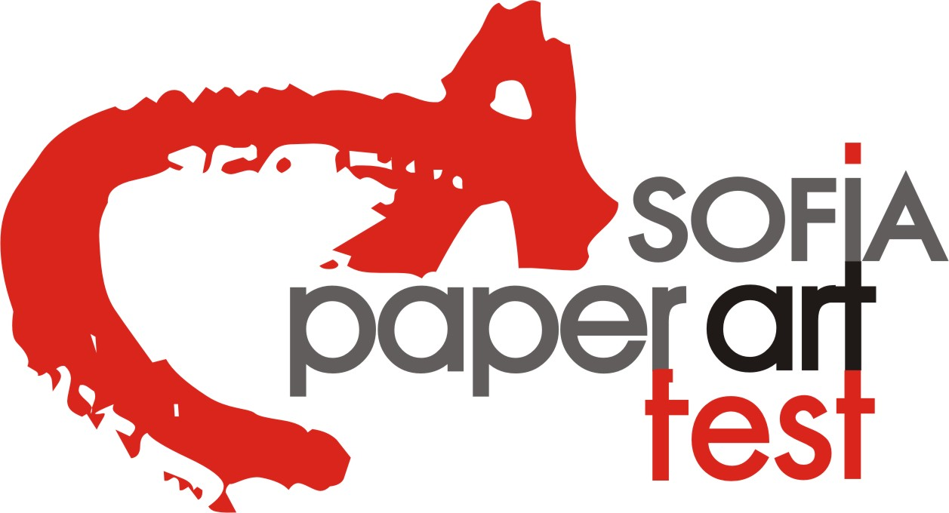

Regulations

9th AMATERAS Annual Paper Art Exhibition/competition is established 2009 and organized by AMATERAS FOUNDATION in Sofia, Bulgaria.
In 2011, AMATERAS exhibition created SOFIA PAPER ART FEST – forum of innovations, experiments and achievements and now This forum is the biggest multidisciplinary festival for Paper Art certificated with European Label for Innovation from EFFE - European Festival Association.

The exhibition is a department of SOFIA PAPER ART FEST for small-size paper art in 2D and 3D. This year will be shown from 10th - 21st of May 2017, in The NATIONAL PALACE OF CULTURE. During the opening ceremony of SOFIA PAPER ART FEST 2017 will be announced the winners.

AMATERAS FOUNDATION had shown last few years traveling collections with presentation in Japan, Italy, Georgia, Poland, Chez Republic, UK, Germany and this year will be shown in many other countries. This is the project of AMATERAS Foundation and Bulgarian Ministry of Foreign Affairs, Bulgarian Cultural Institutes of Ministry of Culture and some Bulgarian Embassies, foreign organizations and museums abroad.

Aim

The main aim of the exhibition is to create a tradition in the presentation of contemporary 2D and 3D small-size paper art, created by artists from all over the world without restrictions of techniques, styles or kind of paper. The purpose of the exhibition is to stimulate the development of creativity and innovations and to exceed the ordinary imagination of using paper and to promote the exchange of ideas and sharing of original experiments.

Eligibility

All artists or art students from all over the world without any restrictions regarding age or specialty are eligible to apply.

Application procedure

The application procedure will be in four stages as described below:

Stage One: Sending of the application materials

Deadline 1 of March 2017 - via email only

Application materials arriving after this date will not be examined.

To enter this competition, please send the following materials:
- No more than 3 digital Images of paper works for the exhibition – 600/800dpi in jpg. format
- CV – short, A4 in doc. format in English and web if have. This information is important for the catalog and web presentation, not for the selection.
- Personal photograph – 400/600dpi. in .jpg format
- Filled in application form – titles, dimensions and media/technique description. The actual size of the works for this exhibition must be no more than A4 or 15/15/20cm.
- Copy of money transfer document showing the payment of the application fee of 40 Euro, via email – the address is stated below.

Works selected for the exhibition will be published on the website www.amateras.eu of the exhibition on March 22, 2017
Selection results will also be sent to the selected artists by e-mail on March 23, 2017 if an e-mail address is stated on the application form.

Application materials must be sent via email only before March 1, 2017 to:
Organizer: Daniela Todorova, M.A.
paperart@amateras.eu

- Stage Two: Sending the original paper works selected in Stage 1.

Deadline April 25, 2016 – last time to arrived in Sofia
Works have to arrive in Sofia, Bulgaria, no later than the deadline.

- Originals arriving after this date will not be included in the exhibition.
- The organizer is not responsible for any loss or damage sustained during transportation.
- The works should be sent to Daniela Todorova – AMATERAS Annual Paper Art Exhibition 2017 as PRINTED MATTER by registered air-mail in a simple packet, unframed, without mounting, bearing the declaration "No commercial value". Please notice: Packages with declared value amounts arrive directly in the customs office, and they will be returned back from the customs office at the expense of the sender.
- All selected works must be legibly labeled with the titles, dimensions, media, and dates of the work.
- Authors of 3D works will be informed by email after the end of exhibition about covering the return price of transport expenses. Return of 2D works is included with the application fee.
- 2D works and works with relief have to be with prepared hanging system by the artist. If such not exist, the organizers reserved the right to expose the work according to their possibilities and if this is against the entirety of the work, the organizers don’t take any responsibility. If this embarrass or threaten other works, the organizers reserved the right not to expose the work having such a problem.
Accepted works must be sent to the address below:

Person: Daniela Todorova
Address: AMATERAS Foundation
16a, Vishneva Str,
1164 Sofia, Bulgaria
Tel: 00 359 898 408868, 00359 878 408863

- Stage 3 - the Exhibition

- Exhibition dates are May 10 – May 21, 2017 at the National palace of Culture, Sofia, Bulgaria

- Works will be for sale with a 10% VAT.
- Taxes for send the payment of sold works is for the artists
- Exhibition news will be published in all media and newspapers
- Exhibition will be publicized widely and advertised in all media. Art critics, curators, collectors and art lovers will all be invited. The organizers will also invite representative persons of foreign cultural institutions in Sofia.
- The artists will be informed if their works are sold, and the money will be transferred to their bank accounts after 10% VAT and taxes for sending.
- During the exhibition AMATERAS FOUNDATION will organize presentation of winning artists and world paper events and organizations.
- During the exhibition will be organized workshops and PAPER PARADE in the NIGHT OF THE MUSEUMS AND GALLERIES.
- If some of selected artists would like to come in Bulgaria please inform organizers.

- Stage Four : Return of the originals

All applicants will receive the catalog of the exhibition and their works back by end of the year 2017 or in January 2018.

Conditions for returning of the works:
- 2D works – return is included in the application fee
- Authors of 3D works will be informed by email after the end of exhibition about covering the return price of transport expenses.
- If the artist would like to donate the works to the organizers, this should be stated on the application form by checking YES or No. AMATERAS FOUNDATION will present representative selection of donated works to their special exhibition in other cities in Bulgaria and abroad. The selection will be made according to the requirements of the exposition space and context of the event. The purpose of this exhibition is to show different directions and styles. All artists will be informed about these future plans. This year is plan exhibition in London, UK.

Entry Fee

- The Entry Fee of 40 Euros helps to cover the cost of a catalogue, gallery rent, the organization of the exhibition, and advertising materials, PR campaign and postage expenses for 2D materials.

- Method of payment: Checks are not acceptable.
Recommended methods of payment are as follows:

  - Bank transfers made to:

Bank: TB Allianz BULGARIA
Using IBAN: BG 59 BUIN 7220 1442 356 716
BIC: BUINBGSF
Recipient: Daniela Todorova
Reason of payment: application fee for AMATERAS Annual Paper Art Exhibition 2017

- Pay Pal
paperart@amateras.eu

- Postal Money Order from the post office:
International Postal Money Transfer Orders made to the name of Daniela Todorova, MA /founder and curator of AMATERAS FOUNDATION/.

Recipient: Daniela Todorova
Address: 16a, Vishneva Str.
City: 1164 Sofia,
Country: Bulgaria, EU
0898 408868

  - COINSTAR (TRAVELEX), MONEYGRAM

Recipient: Daniela Todorova
Address: 16a, Vishneva Str.
City: 1164 Sofia,
Country: Bulgaria, EU
0898 408868

Jury

Selection will be made by an international jury of art experts. The decisions of the jury are final.

Prizes and Awards:

- Grand Prix AMATERAS 500 Euro & Certificate

- Award for INNOVATION 200 Euro & Certificate

- Award for YOUNG ARTIST 200 Euro & Certificate

- Award for Bulgarian artist Exhibition and Certificate

- One Special Certificates for versatility of all 3 entries winner

- Three Certificates for Honorable Mention (good/high performance)

- The works of 4 price winning artists will be owned by AMATERAS FOUNDATION, and will be exhibited in other future exhibitions.

- The money from Prizes and sold works will be send to artists after end of the exhibition, or the end of 2017.

- First Four Winning Artists and the Four Honorable Mention Artists will be welcome to exhibit at the AMATERAS Annual Paper Art Exhibition 2017 without an Entry Fee.

Rules for publishing:
- AMATERAS FOUNDATION reserves the right to photograph all works, advertise them and publish all materials on the CD, catalog, and website of the exhibition and for all other needs.
- Unless specified by the artist, all files will be kept in the library of the organizers, and all applicants will be informed in the future about events organized by AMATERAS FOUNDATION.
- All participating artists will be presented on the website of AMATERAS Annual Paper Art Exhibition.
For further questions please email to:

Contact person: Daniela Todorova, M.A.:
E-mail: paperart@amateras.eu

Please fill out in English the entry form for stage one and send it without regulations:

ENTRY FORM

Name ……………………………………………………………………………………………………………….

Surname………………………………………………………………………………………………..................

Address …………………………………………………………………………………………………………….

Nationality ………………………………………………………………………………….................................

Member of IAPMA ……………………..………………………………………………………………...........

E – mail: ………………………………………………Web………………………………………………...

Tel.: …………………………………………………………Fax:………………………………………………...

Date of birth ……………………………………………Place…………………………………………….

Education………………………………………………………………………male…………female…………

LIST OF WORKS ENTERED FOR STAGE ONE:

1. Name of work……………………………………………………………………………donate………
Media…………………………………………………….year…………….size…………….price…………

2. Name of work……………………………………………………………………………donate………
Media…………………………………………………….year…………….size…………….price…………

3. Name of work………………………………………………………………………… donate………
Media…………………………………………………….year…………….size…………….price…………

DESCRIPTION OF PAPER OR TECHNIQUES USED:

……………………………………………………………………………………………………………………….

……………………………………………………………………………………………………………………….

……………………………………………………………………………………………………………………….

I accept the rules and regulations of AMATERAS Annual Art Paper Exhibition 2016
Please use YES or NO for part donation.

paperart@amateras.eu Signature

Please fill one label for each selected work for
stage two and put on the back of the work or toghetehr with the work

Name………………………………………...

Surname……………………………………...

Nationality………………………………..….

e-mail………………………………………...

Name of work ..…………………………..

…………………………………………..…..

Size………………year……………..………

Media…………………………..……………

………………donate………………………..

Name………………………………………...

Surname……………………………………...

Nationality………………………………..….

e-mail………………………………………...

Name of work ..…………………………..

…………………………………………..…..

Size………………year……………..………

Media…………………………..……………

………………donate………………………..

Name………………………………………...

Surname……………………………………...

Nationality………………………………..….

e-mail………………………………………...

Name of work ..…………………………..

…………………………………………..…..

Size………………year……………..………

Media…………………………..……………

………………donate………………………..

